Pirate Radio
Yeah you are not trippin'. You can easily make a FM Transmitter out of your Raspberry Pi! You don't even need hardware hacking skills. It's an out-of-the-box feature.
First you need to download this binary which does all the magic for you: PiFM.tar.gz
Run it with sudo ./pifm sound.wav 100.23
The last bit of the command is the frequenzy you want to use. You can also jam nearby radios as your signal will be a lot stronger than the "normal" radio signals on this very frequency.
sound.wav must be a 16 bit mono wav
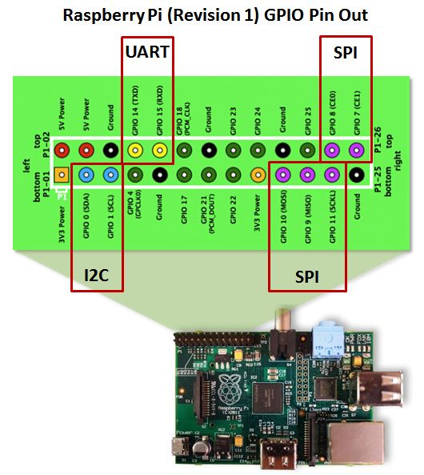
Now you want to reach a bigger area. You can achieve this by simply attaching a plain wire (+- 20cm) to the GPIO4 (CPCLK0) which will act as an antenna. Use a paperclip to held the wire against the pin. For a final solution you can weld it all together.

