Digital Rights Ireland Conference 2015
Since 2008 C3L tries to raise a awareness for privacy and the fact of having a transparent government, instead of a transparent citizen. It's hard and rock way.
Here, in Eire, the NGO Digital Rights Ireland, organized a conference about privacy, data protection and data security in general.
The schedule is quite busy and parallel talks seem to be the normal way of procedure as well.
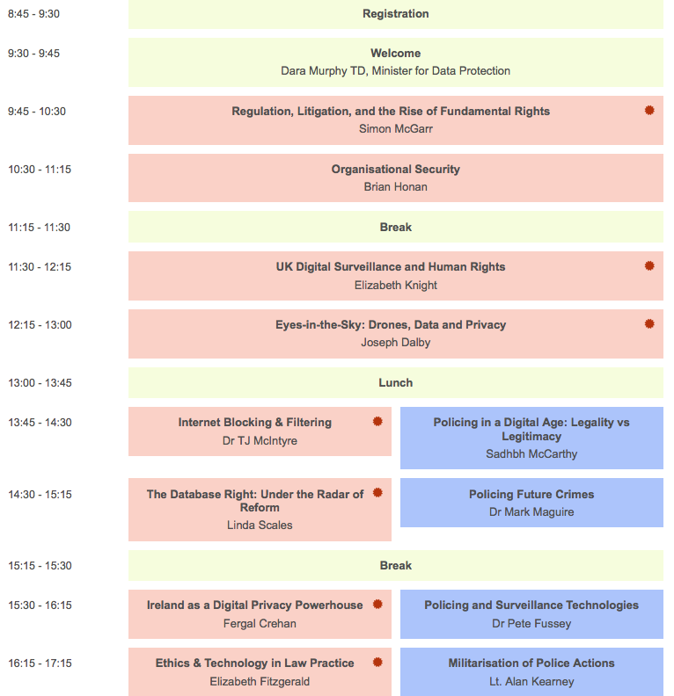
We'll keep you up to date from DRE2015 in this very post here.
chrescht & prometheus

