Mini Maker Faire Luxembourg
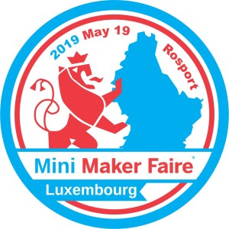
Date | 19/05/2019 10:00-18:00
Venue | Rosport
Description
Website | https://luxembourg.makerfaire.com/
Contact | metalgamer
Participants | deflenken, virii, orimpe, staybehind, fantawams
- Game of Life + Kits
- Seismograph + Traffic Light
- metalgamer & fantawams's 3D Drucker
- fantawams & orimpe's EggBot
- Lockpicking Set's
- Memberskaarten C3L
- Router
- Caisse fir Spenden
- metalgamer Network Marquee (maybe not finished until then)
- USV

