Hack.lu 2013
"Hack.lu is an open convention/conference where people can discuss about computer security, privacy, information technology and its cultural/technical implication on society. The aim of the convention is to make a bridge of the various actors in the computer security world. The conference takes place at Parc Hotel Alvisse in Luxembourg the 22-24 October 2013." (Source)
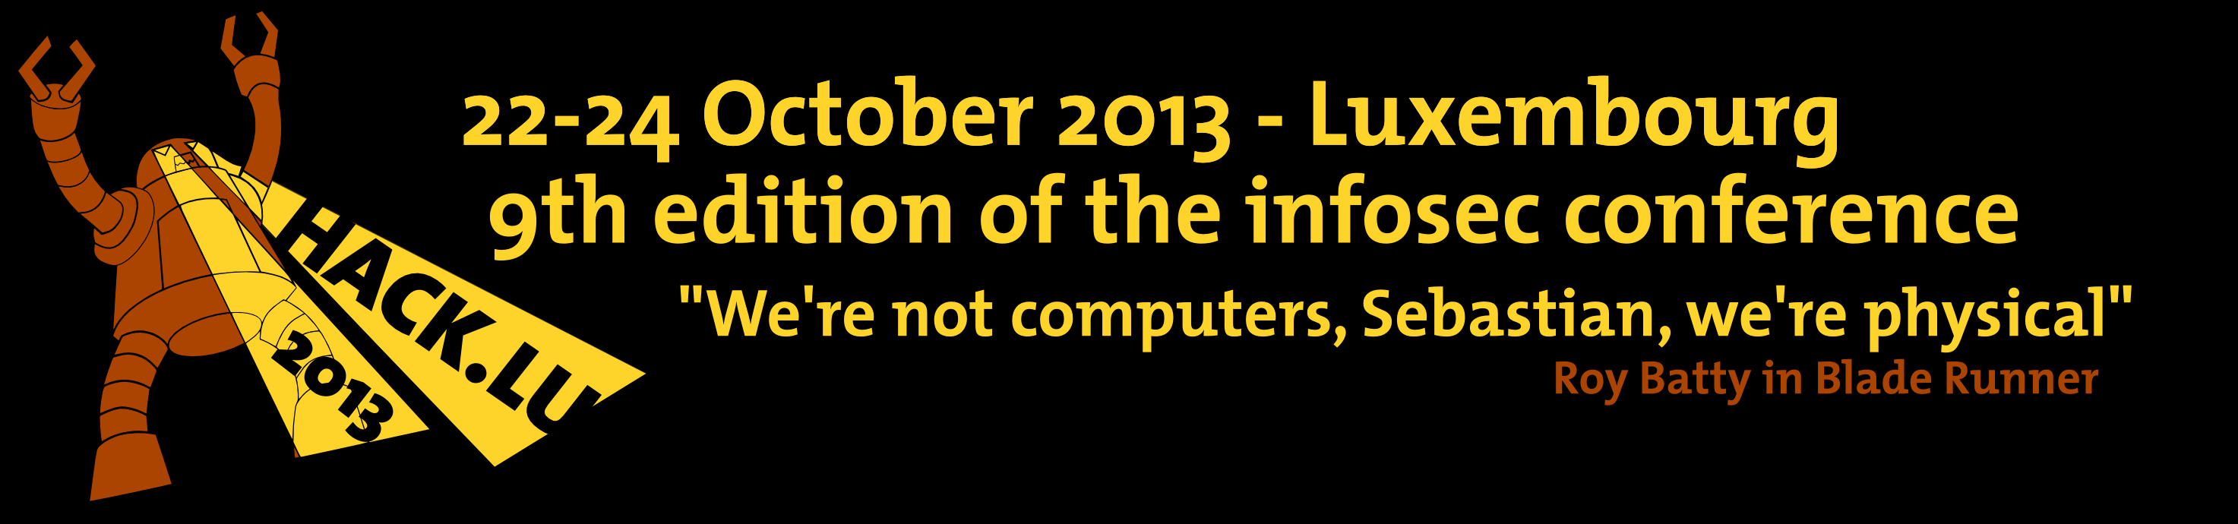?1000 |
Every member of C3L whom would like to attend, please register your name under attendees and make sure we'll be able to contact you. info@c3l.lu

Activities
What activities will we off this year?
- UltiMaker
- LockPicking
- Bulding Antenna's

Merchandise
- T-Shirts
- PirateBoxs'
- Pi's (ld)
- Books
- Onions
- Stickers & Posters

Preparations

Stuff
Stuff we'd like to show off on our booth:
- Banners
- Lockpicking Set
- Books
- …

List of attendees
- prometheus
- virii
- freak_out & friend (on hold)

