Tin foil hat - Area
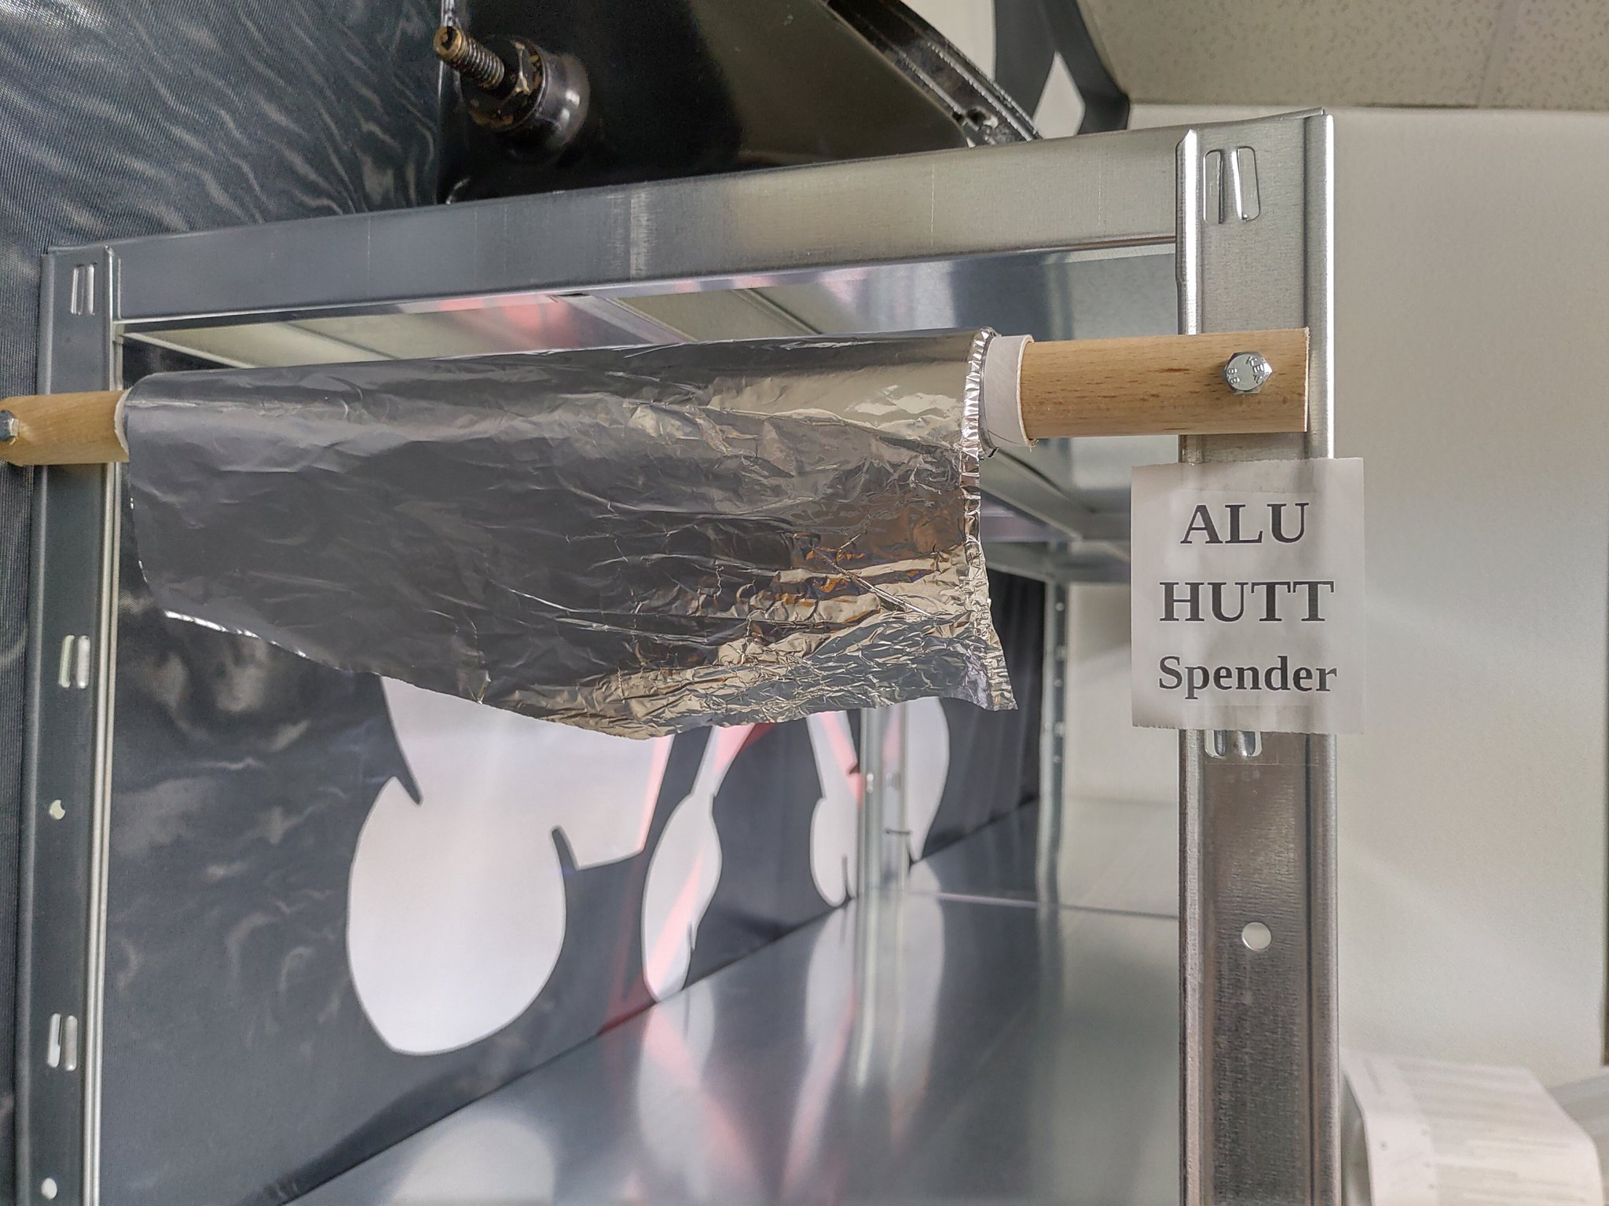
Some assembly required
Ready-for-assembly Tin foil hat is possible and encouraged in case of imminent alien invasion, conspiracy or paranoid feelings.

