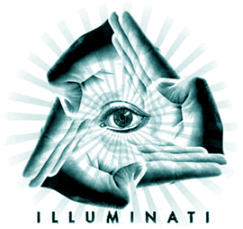

Conspiracy Night
Free masons ruling our world? Rothschild is part of a reptilian race? Annunaki created us? Is the Bilderberger group leading every step of mankind?
This and much more can be discussed at our Conspiracy Nights. Feel free to alluminate us with your theories!

Where?
Conspiracy nights are usually held at the syn2cat Hackerspace. If the location differs you will find a notice at the wiki.

Nights
- Conspiracy Night #0
- Conspiracy Night #1
- Conspiracy Night #2
- Conspiracy Night #3
- Conspiracy Night #4
- Conspiracy Night #5
PDF documents, pictures and everything related can be shared via the local PirateBox!

