German Version

World Wide Open Hackerspace Day
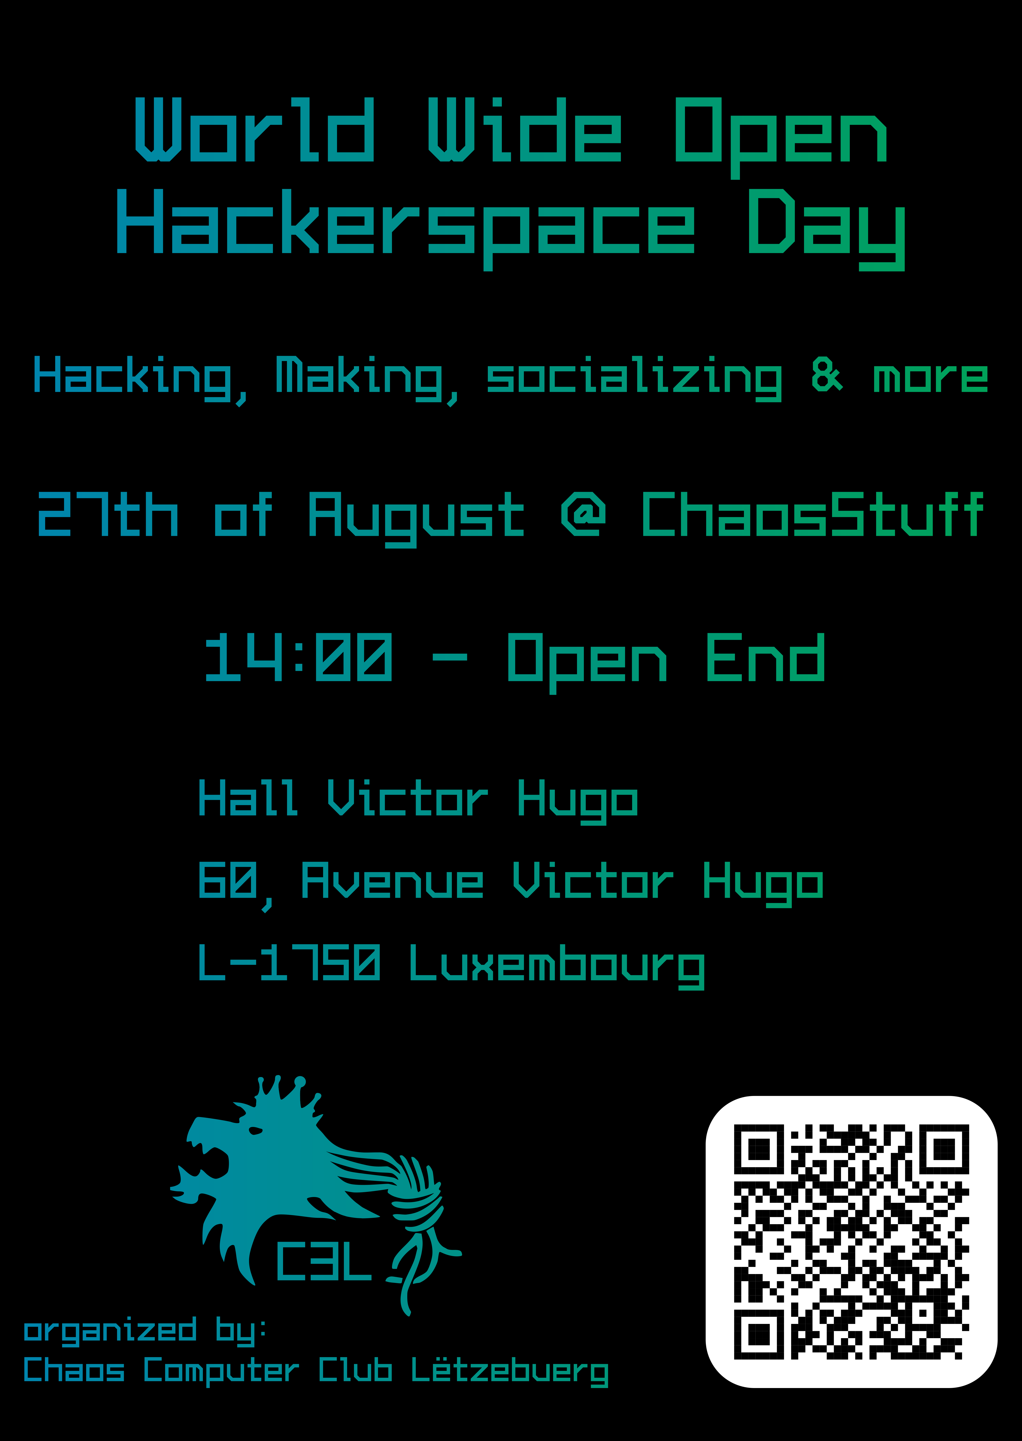
Date | 27/08/2022 - 14:00
Venue | ChaosStuff
Description
Website
Contact | metalgamer
Participants
We are opening our doors in over fifty hackerspaces on 27 August and hope for many visitors.
The Chaos Computer Club Luxembourg (C3L) invites you to the Open Hackerspace Day on 27 August 2022. We want to introduce ourselves, show projects, open up to guests and anyone interested, and perhaps dispel a few hacker myths in the process.
Hackerspaces are open places for the creative use of technology. Not only are tools such as 3D printers and electronics labs available there, but they also provide the space where hackers, makers and hobbyists meet to exchange ideas and work on projects together.
More than fifty Hackerspaces will join in and open their doors across Germany and in Switzerland and Luxembourg. The spaces and projects are as diverse as the interests of the CCC activists who meet and get involved in them.
Come in large numbers!

