Cryptoparty

The Cypherpunks are actively engaged in making the networks safer for privacy. Let us proceed together apace. ~ Eric Hughes

A Definition
"Interested parties with computers, devices, and the willingness to learn how to use the most basic crypto programs and the fundamental concepts of their operation! CryptoParties are free to attend, public and commercially non-aligned. CryptoParty is a decentralized, global initiative to introduce basic cryptography tools - such as the Tor anonymity network, public key encryption (PGP/GPG), and OTR (Off The Record messaging) - to the general public." (Source: A CryptoParty History: Party Like It's 1984)
Thus the statement above, a cryptoparty, which has risen from the cypherpunk movement, is more to hackers than just a meet-up between people, discussing real world surveillance issues.

Cryptographic Party in Luxembourg?
Name | When | Where | Version
cryptoParty - Onward | 12th of January '13 @ 10 AM | Centre Barblé  rue des Romains  L-8041 Strassen | 0.1
cryptoParty - Let's hack towards a better future! | 18th of March '15 @ 19 PM | Carré Rotondes 1,  rue de l’Aciérie  L-1112 Luxembourg-Hollerich | 0.2
cryptoParty - Let's hack towards a more private future! | 18th of November '15 @ 19 PM | Rotondes,  Place des Rotondes,  L-2448, Luxembourg-Bonnevoie | 0.3

Cryptography
Cryptography is something a lot of people take a step back, as they think they're no able to handle it. Well that's the place where the following resource come in very handy:
- Everything you need to know about cryptography in 1 hour by Colin Percival
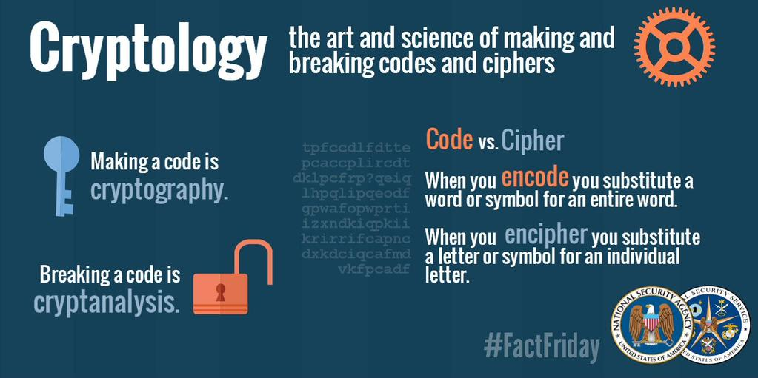

Read / Watch on!
- CryptoParty.org
- CryptoParty - Handbook
- Wikipedia - CryptoParty
- https://crypto.is/

Publicity
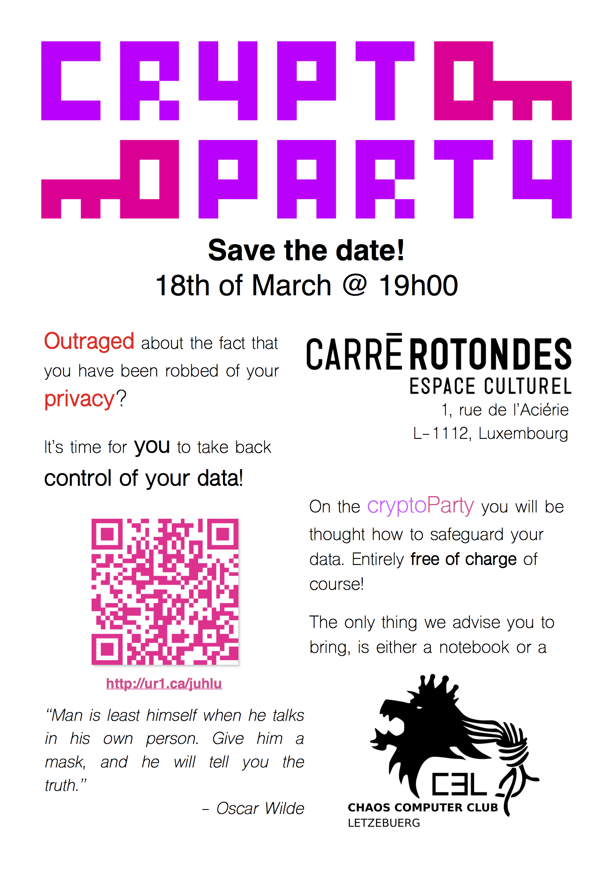
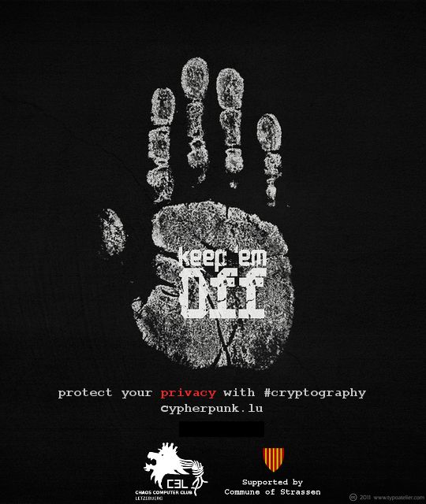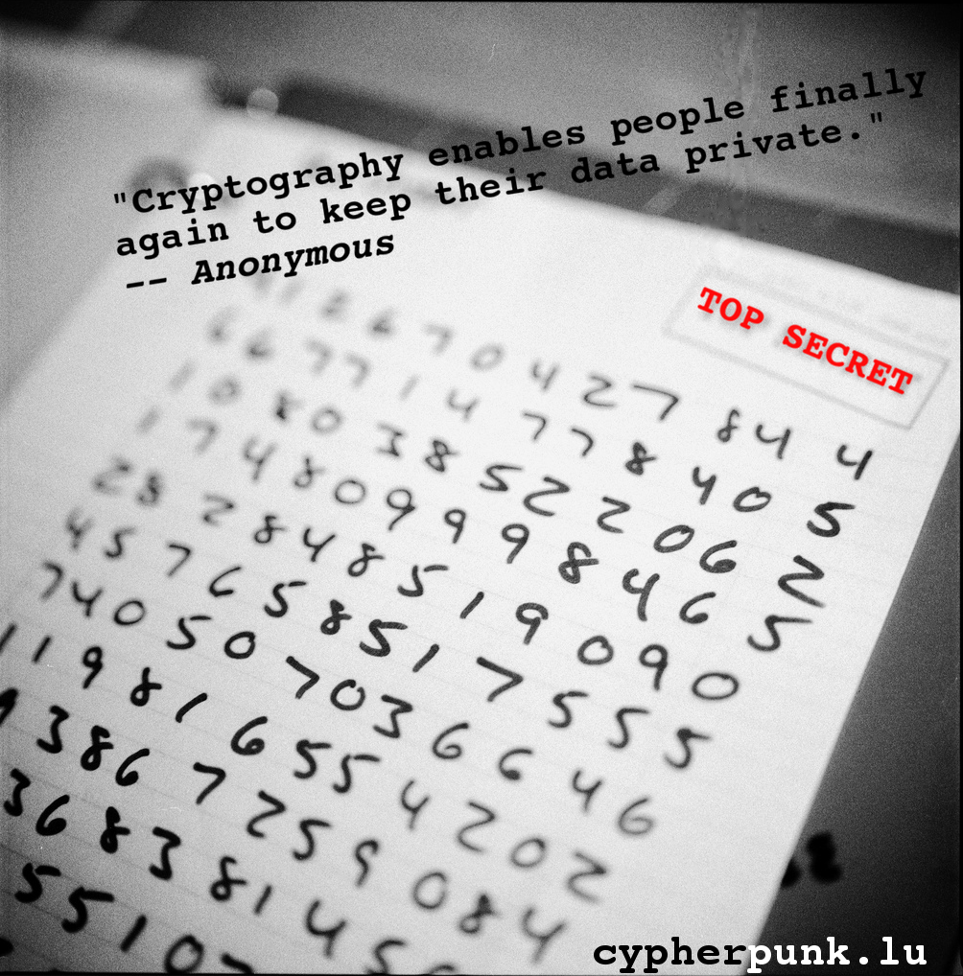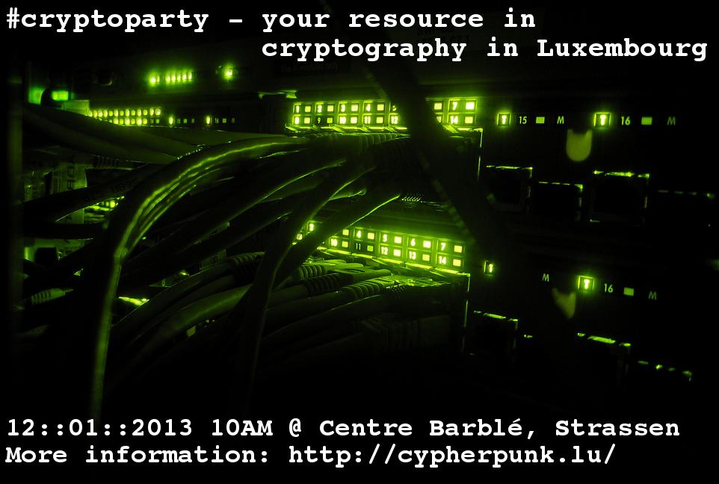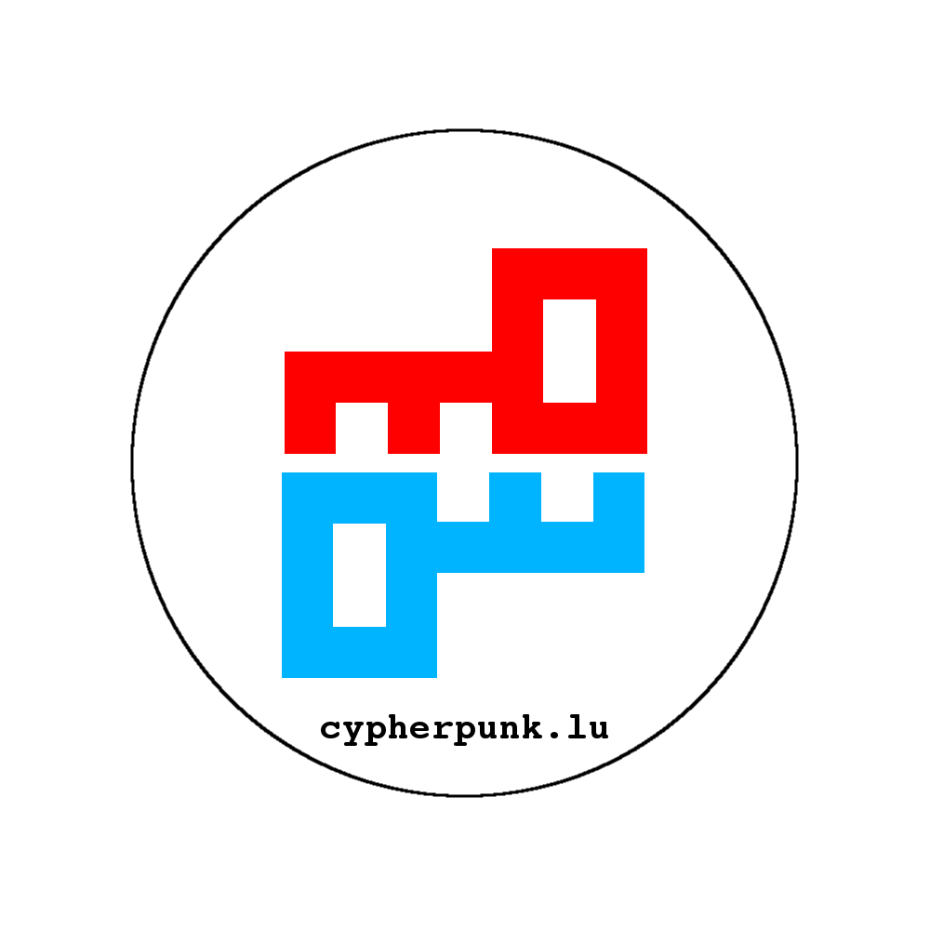

Artwork


