#SaveYourInternet
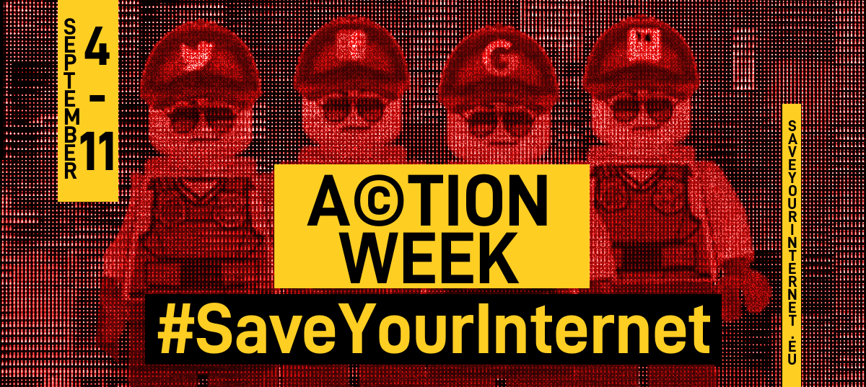

Article 13 is bad for the Internet as a whole: Over 70 Internet pioneers and experts have rallied behind Sir Tim Berners-Lee to address an open letter, on 12 June 2018, to the European Parliament wherein they urge MEPs to vote for the deletion of Article 13 for the sake of the Internet’s future, as it “would mandate Internet platforms to embed an automated infrastructure for monitoring and censorship deep into their networks”.
Article 13 is bad for EU citizens’ fundamental rights: Over 50 NGOs representing human rights and media freedom addressed an open letter, on 16 October 2017, to the European Parliament asking MEPs to delete Article 13, as it “would violate the freedom of expression set out in (…) the Charter of Fundamental Rights” and “provoke such legal uncertainty that online services will have no other option than to monitor, filter and block EU citizens’ communications”.
Article 13 threatens legal certainty in the EU: Academics from 25 leading Intellectual Property research centres in Europe have published Statement of 29 June 2018 entitled 'The copyright Directive: Misinformation and Independent Enquiry'. This follows an open letter of 26 April 2018, pointing out that there is scientific consensus on the fact that Article 13 “threaten[s] the user participation benefits of the e-Commerce Directive (2000/31/EC)”.
Article 13 will be bad for the European economy: European innovative media publishers have expressed their concerns around Article 13, who consider that “these rules are bad news for publishers who rely on an open and competitive internet to source, create and disseminate stories to their readers”. Allied for Startups, an organisation representing start-ups in Europe, explains that “the suggested filtering technology will raise the cost of launching a startup in Europe and drive talent away”.
The Parliament must promote a balanced and evidence-based approach to copyright enforcement and not fall into the trap of so-called ‘easy fixes’ to the detriment of our fundamental rights.
<html><center><iframe width="560" height="315" src="https://www.youtube-nocookie.com/embed/89ZkydX0FPw?rel=0" frameborder="0" allow="autoplay; encrypted-media" allowfullscreen></iframe></center></html>

